Presentation to:

Honourable David Zimmer,

Minister of Aboriginal Affairs

Algonquin Land Claim

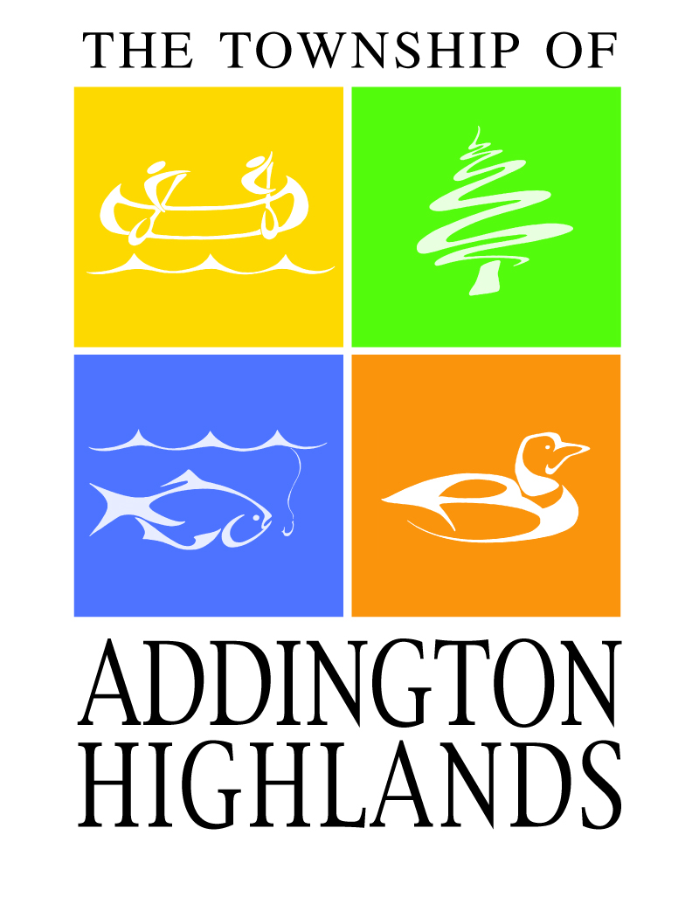

Township of Addington Highlands

Reeve Henry Hogg

January 9, 2014

Summary of points raised in Henry Hogg’s Presentation to David Zimmer, Minister of Aboriginal Affairs:

* Total cost of this Claim to be at least $3 billion dollars, will be paid by Ontario taxpayers who have had no say
* The costs which might fall to the municipalities are a grave concern…… Providing fire protection, policing and ambulance service as well as roads will cost far more than the taxes from increased assessment will provide
* reduced assessment on adjacent lands due to the uncertainty of possible uses of "Settlement Lands"
* Access to both private property and crown land across the settlement lands is a concern
* Federal, Provincial and Algonquin negotiators developed a "Tripartite Statement of Shared Objectives" ….. "to continue to consult with interested parties throughout the negotiation process” …..This did not happen.
* Bon Echo Provincial Park ……. is a major employer of summer students. If the Park is to be co-managed with the Algonquins this could cause major job loss to area student

Mr. Minister:

First, I would like to thank you for this opportunity to meet with you.

The Township of Addington Highlands was created in 1998 from the former

Townships of Denbigh, Abinger and Ashby and Kaladar, Anglesea and Effingham and is the entire northern portion of Lennox and Addington County. Approximately 75% of Addington Highlands is Crown land and the most of this Crown land lies within the Algonquin Land Claim.

I have included a map showing the affected area of our Township

The township is sparsely populated with about 2500 permanent residents and nearly the same number of seasonal residents (cottagers) and very limited commercial enterprise. This all leads to a very limited assessment base for the Municipality to operate on.

Over the years it has been a struggle to provide necessary services to our inhabitants and they have also struggled with very limited job opportunities.

These taxpayers and their predecessors have created the existing infrastructure over many years.

I operated my own business in Addington Highlands for over 30 years and my wife and I raised our family here

This is my 4th term as Reeve of Addington Highlands and I have been the Lennox & Addington County representative on the Municipal Advisory Committee for most of this time.

It was never my feeling that this Committee was ever able to act as Advisors but were merely given information which was always "confidential" and could not be discussed with our constituents.

The total cost of settling this Claim has been estimated to be at least $3 billion dollars, all of which will be paid by Ontario taxpayers who have had no say in the process.

The costs which might fall to the municipalities are a grave concern to all taxpayers involved.

Most statements have not been firm about costs, for instance Mr. Crain in his letter dated April 25,2013 said: We do not intend that such implementation costs will fall on municipalities: not very definite. He also states that services to settlement lands may be required by law.

Page 2 - Presentation to Minister David Zimmer

Providing fire protection, policing and ambulance service as well as roads will cost far more than the taxes from increased assessment will provide.

While the settlement lands may be zoned "limited services" due to their remoteness, it has been my experience that once taxes are paid, all services will be expected.

There will also be costs to municipalities in regard to reduced assessment on adjacent lands due to the uncertainty of possible uses of "Settlement Lands"

While these lands will be subject to taxation, what recourse will municipalities have if these taxes are not paid?

Access to both private property and crown land across the settlement lands is a concern despite assurances that this will not be jeopardized. One only has to look to Deseronto where Shaun Brant and his associates (Mohawks) have threatened to block Hwy # 401 and major railway lines to realise why these concerns exist.

Federal, Provincial and Algonquin negotiators developed a "Tripartite Statement of Shared Objectives" during preliminary negotiations and reaffirmed them in 2006. The final of these was "to continue to consult with interested parties throughout the negotiation process and to keep the public informed of the progress of negotiations.

This did not happen and we were presented with a "Preliminary Draft Agreement" without consultation.

I have included information taken from Brian Crane's 2010 "Algonquin Land Claim Update.

Bon Echo Provincial Park is partially within Our Township with the remainder including most of the campsite being in the Township of North Frontenac. The Park is a major employer of summer students. If the Park is to be co-managed with the Algonquins this could cause major job loss to area students

Statements have been made but I have not been able to verify them, that since the "Land Claim" predates our Township Official Plan and Zoning Bylaws, these would not apply to settlement lands which could lead to improper use of these lands.

Will there be Public consultations prior to any further negotiations?

Public consultations seem to be promised regularly in correspondence but to this date have not occurred.

Page 3 - Presentation to Minister David Zimmer

There is a municipal election coming in Oct, 2014 and I am certain that these issues will be at the forefront. Vague answers or promises will not be acceptable and are not my style. I need firm answers.



Reference from - Algonquin Land Claim Update - September 2010

A Message from Brian Crane, Chief Negotiator, Ontario - Page 7

**Statement of Shared Objectives**

Early in the negotiation process, the three parties agreed to some guiding

principles that would form a common understanding as the talks proceed. When active negotiations resumed in 2006, the original Statement of Shared Objectives was revisited and it was agreed that the principles remain relevant. The following Affirmed Statement of Shared Objectives was signed by the three principal negotiators and by the 16 Algonquin Negotiation Representatives in March 2006.

**2006 Statement of Shared Objectives**

Originally signed by the Chief Negotiators for Ontario, Canada and the

Algonquins of Golden Lake First Nation in August 1994, the attached Statement of Shared Objectives will continue to guide us during our negotiations.

In re-affirming their commitment to these shared objectives, the parties recognize that they are doing so without prejudice to their legal positions.

The parties also acknowledge the concerns of the Algonquins of Ontario to protect Algonquin interests in the lands within the claim territory in regard to contemplated dispositions or alienations during the course of negotiations.

**Shared Objectives**

Following the first phase of public consultations, we have identified a number of shared objectives which will guide us during the course of our negotiations.

We are committed to achieving a just and equitable settlement of the longstanding claim of the Algonquins of Golden Lake First Nation, and in doing so, we intend:

• to avoid creating injustices for anyone in the settlement of the claim;

• to establish certainty and finality with respect to title, rights and interests in the land and natural resources with the intention of promoting stability within the area and increasing investor confidence;

• to identify and protect Algonquin rights;

• to protect the rights of private landowners, including their rights of access to and use of their land;

• to enhance the economic opportunities of the Algonquins with the intention of also benefiting and promoting general economic and commercial opportunities in the area;

• to ensure that Algonquin Park remains a park for the appropriate use and

enjoyment of all peoples;

• to establish effective and appropriate methods and mechanisms for managing the lands and natural resources affected by the settlement, consistent with the principles of environmental sustainability;

• to continue to consult with interested parties throughout the negotiation process and to keep the public informed on the progress of negotiations.